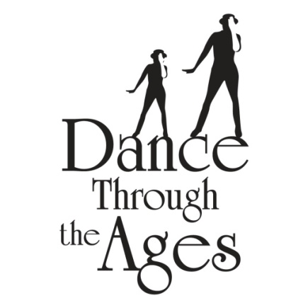
DTTA’s dance recital is a production of DTTA and not your child’s school. We encourage all children to participate in this valuable experience, but participation is not mandatory to take class.

DTTA 2023-2024
Recital Theme!
“When I Grow Up”
Phone: (954) 260-4409 / Email: DTTADance@gmail.com / Web: www.DanceTTA.com
PARENTS, PLEASE READ!
IMPORTANT RECITAL INFORMATION! MARK YOUR CALENDARS NOW!
If you have any questions, please let us know! Specifics will go home as we get closer to the show.

November 9, 2023

Dear Parents,
We are having a wonderful time dancing with your children every week and are already planning a spectacular show for our yearly recital. This is an event not to be missed! Below are all the details you need.

RECITAL FEE: $210.00 -DUE BY DECEMBER 9th (After 12/15 = $225.00)
Everything your recital fee includes!
~ 1 costume/1 pair of tights (girls only) ~
~ 1 video download of complete show to view & share ~
~ 1 Bronze Recital Picture Package with EPS Photography ~
~ Participation ~

*Sibling Discount = $165.00 (includes list above) / *Additional costume discount = $110.00/dance
*Non –refundable after 12/15 ~ no exceptions. Late orders incur a $25.00 late shipping fee/costume
*Shoe/Hair requirements will go home in January. Shoes & tickets are not included in the recital fee.
*We will be measuring all dancers during classes for costume sizing.

RECITAL LOCATION: The Parker Playhouse, Ft. Lauderdale

SHOW DAY: Sunday, May 26th @ The Parker Playhouse – Showtime 11:00 a.m.

PROFESSIONAL RECITAL PICTURE DAYS: April 18th-April 21st @ DTTA –Schedule TBA

TICKETS SALES: On Sale Date TBA – Tickets sold through Ticketmaster
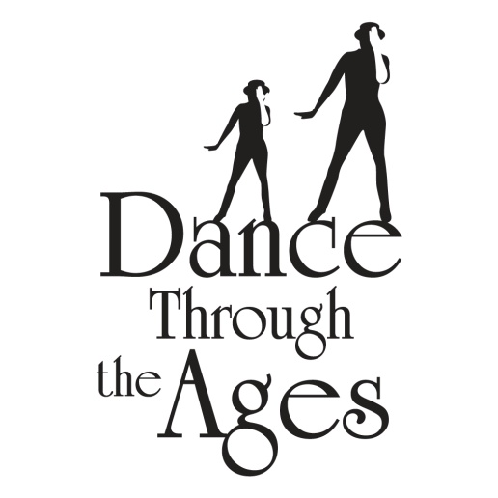
RECITAL PERMISSION FORM
Please fill out this form and return via EMAIL or SEND to us with your recital fee by 12/9/2023
By Email: Send us your signed permission form and you will receive a PayPal invoice to make your recital payment. *PayPal/Credit cards subject to fees* DTTADance@gmail.com
By Mail: Payment can be made by check or money order, made payable & sent to:
Dance Through the Ages
351 SW 136th Avenue, #104
Davie, FL 33325
Recital fee is $210.00 for the 1st dancer; $165.00 Sibling dancer - Please contact us for pricing on additional dances.

Dancer’s Name:________________________________________________________Age:______________

Dancing Location: Brauser Maimonides Academy (Dance & Acro/Cheer Classes)

Parent(s) Name(s):_____________________________________________________

Contact Phone:________________________________________________________

Email:_________________________________________________________________
Please read and sign below: “I have read and understand all the information pertaining to the recital”
I understand that the recital fee is non-refundable after December 15th, 2023, no exceptions!
I understand that the show may be converted to an in-studio performance, based on the current public health crisis, and I may not be able to attend in person, but will be able to view it virtually.
I understand that I am responsible for ticket purchase in order to attend the shows-whether in person or virtual.
I understand that the recital fee includes 1 costume, 1 pair of tights, video, 1 Bronze picture package per dancer I am registering & participation. I understand that there are 2 shows, and if I have more than one child, or take class at my school location & studio location they may be in different shows depending on their classes. I am responsible for ticket purchase to all shows my family and I attend. Tickets are $45/$50 through Ticketmaster(fees apply). I understand tickets are not included in the recital fee and must be purchased to attend/view the show(s). I understand shoes are not included in the recital fee and I will be responsible for purchasing them for my child. I understand that all outstanding balances must be paid in full for my child to receive their costume & participate in the show and all show activities. I understand that costumes are not made to fit like regular clothing and may require minor alterations- they can only be returned if there is a defect. Returns for any other reason will incur a shipping fee, which I will be responsible for. I understand that my child must attend their dance classes in order to participate in the show. I understand that I am responsible for reading all emails and information that is sent to me regarding the show. I understand that both my child and my family must follow all safety protocols DTTA & Parker Playhouse have in place in order to attend the show.
_______________________________________________________ ____________________
Parent Signature Date

